**Evidence Doc**

**Resource Groups -**

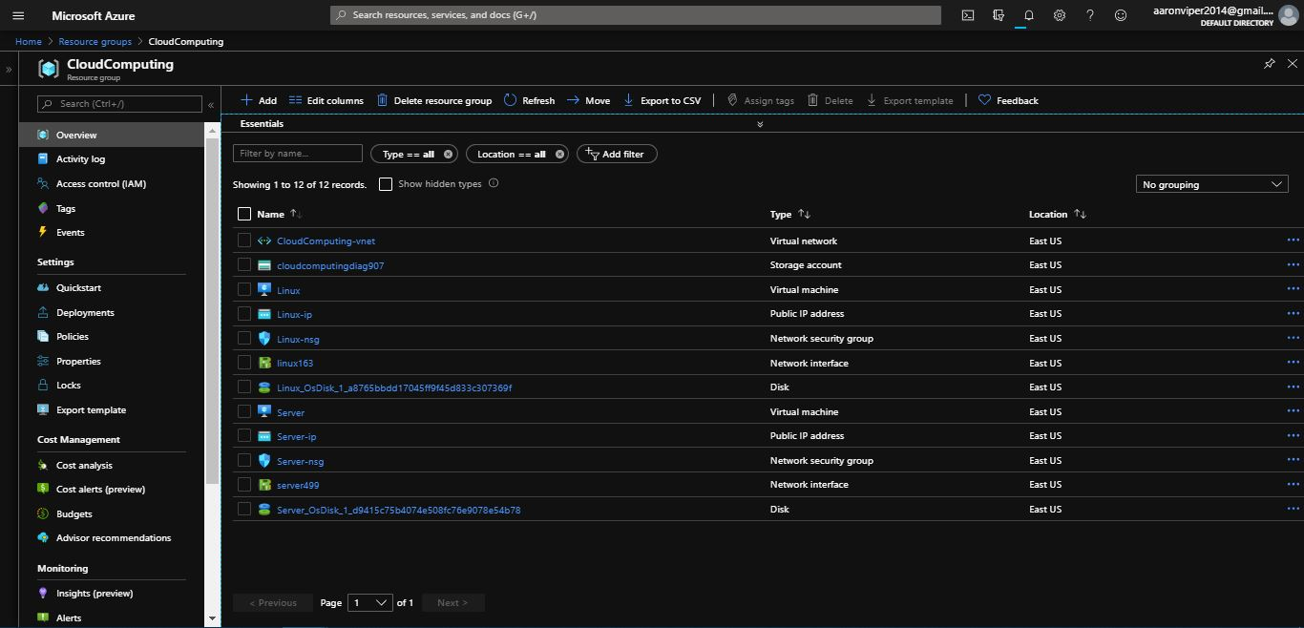

**Kali Linux Virtual Machine -**

**Kali Linux VM Deployment process -**

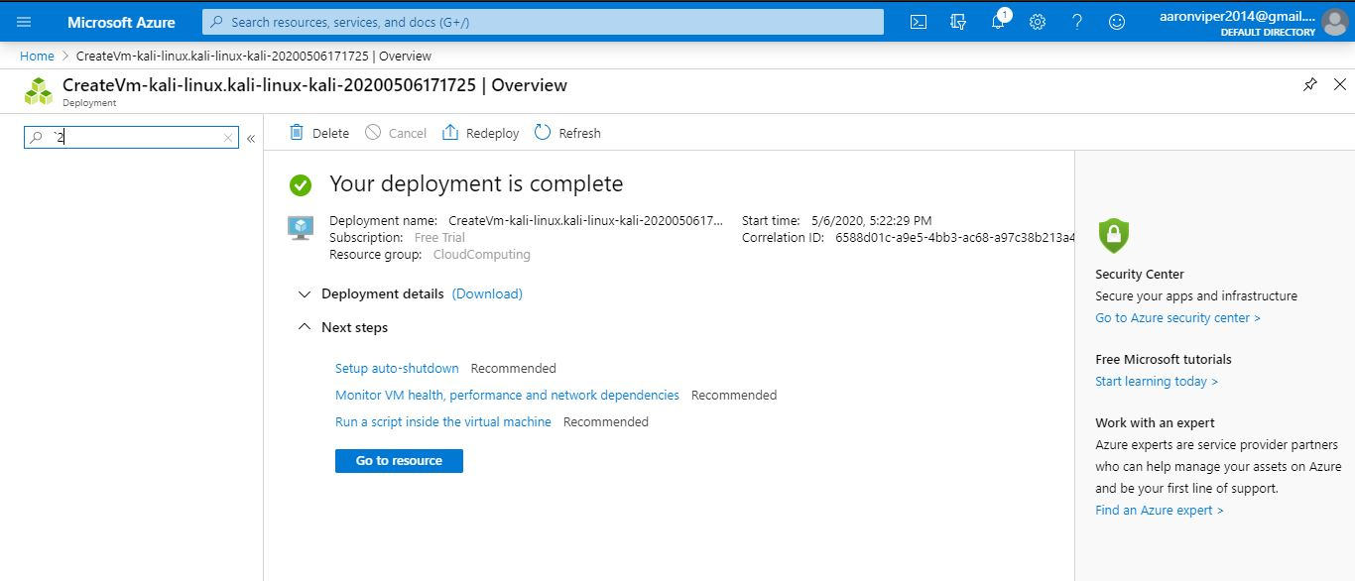

**Kali Linux VM settings -**

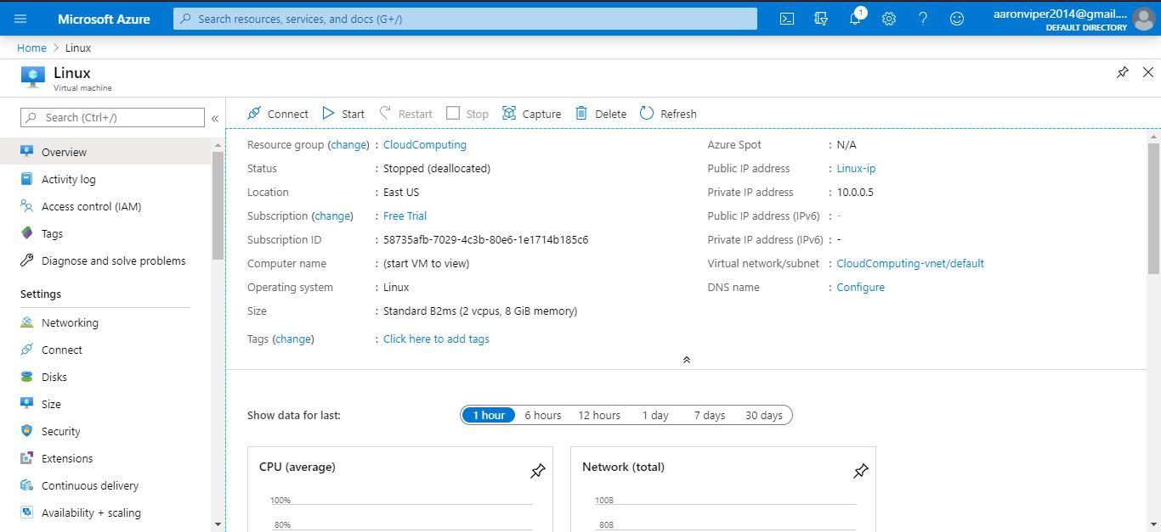

**Windows 10 Pro Virtual Machine -**

**Deployment process for Windows VM -**

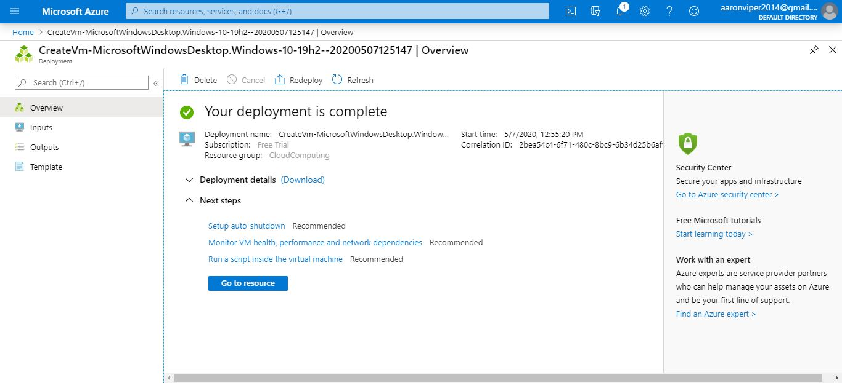

**Windows 10 pro VM Settings -**

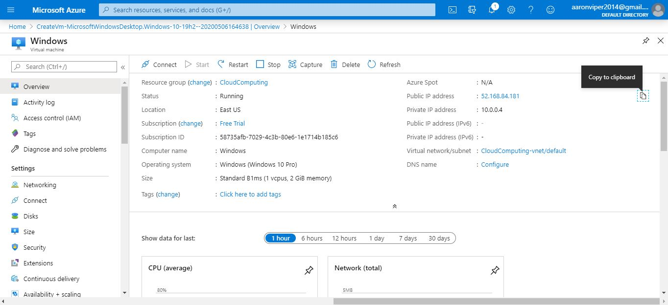

**Verify the functionality of the VMs**

**Kali Linux PuTTY Configuration -**

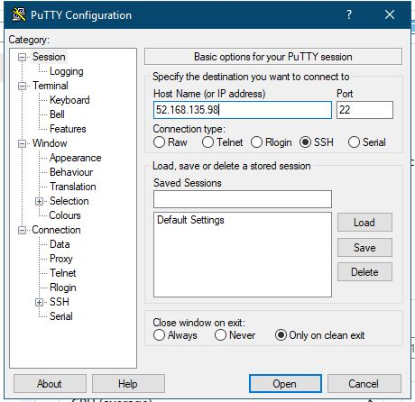

**Kali Linux Terminal login -**

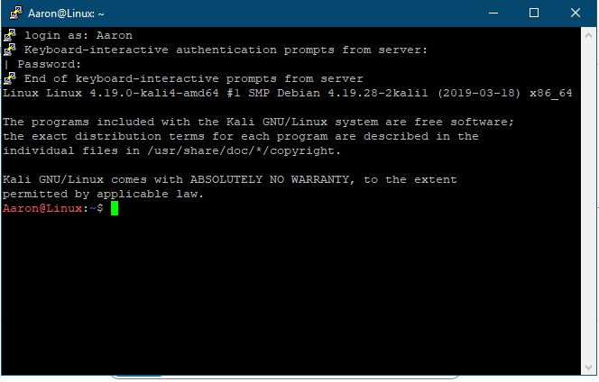

**Windows 10 pro VM Start up / Login Testing -**

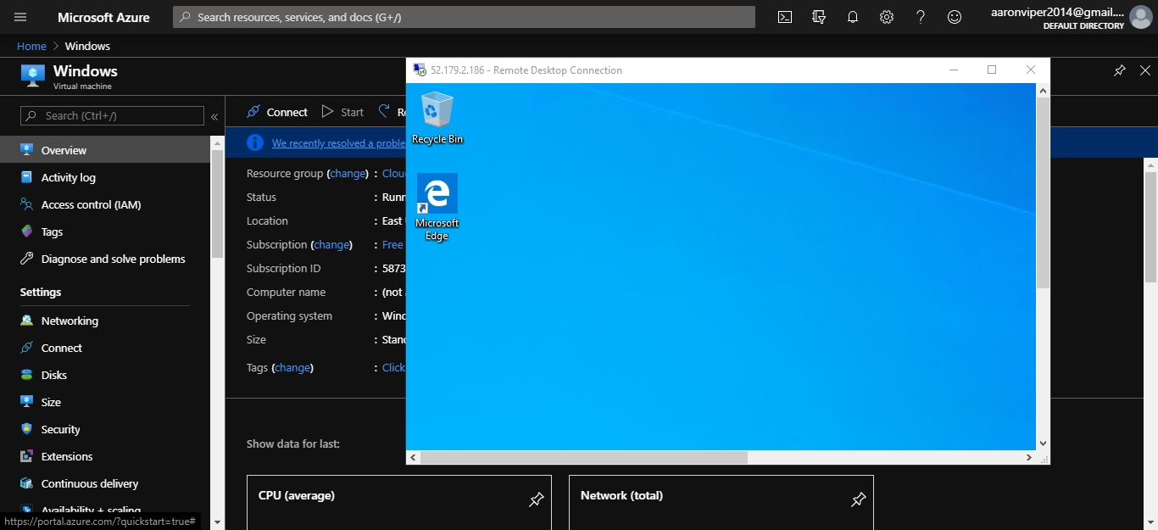

**Test Website Hosting on Azure Server -**

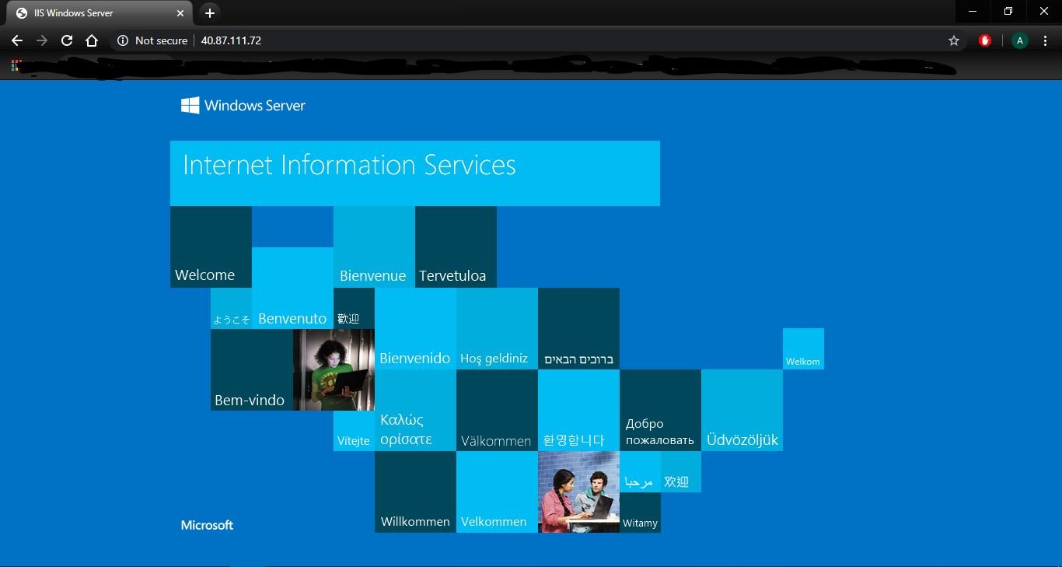

**My Website Hosting on Azure Server -**

**Home Page -**

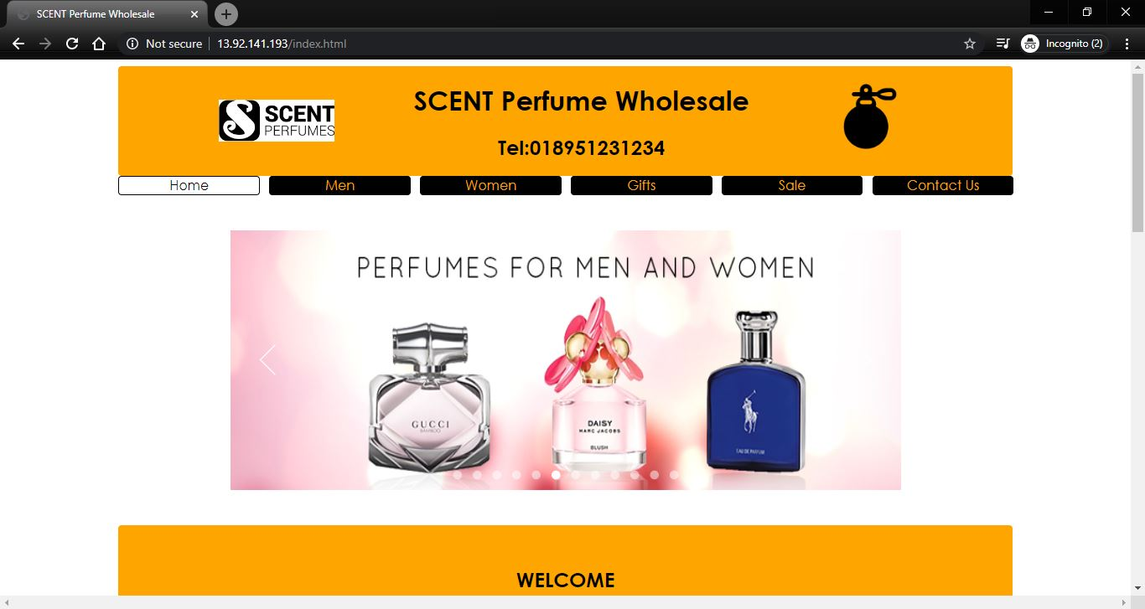

**Men’s Page -**

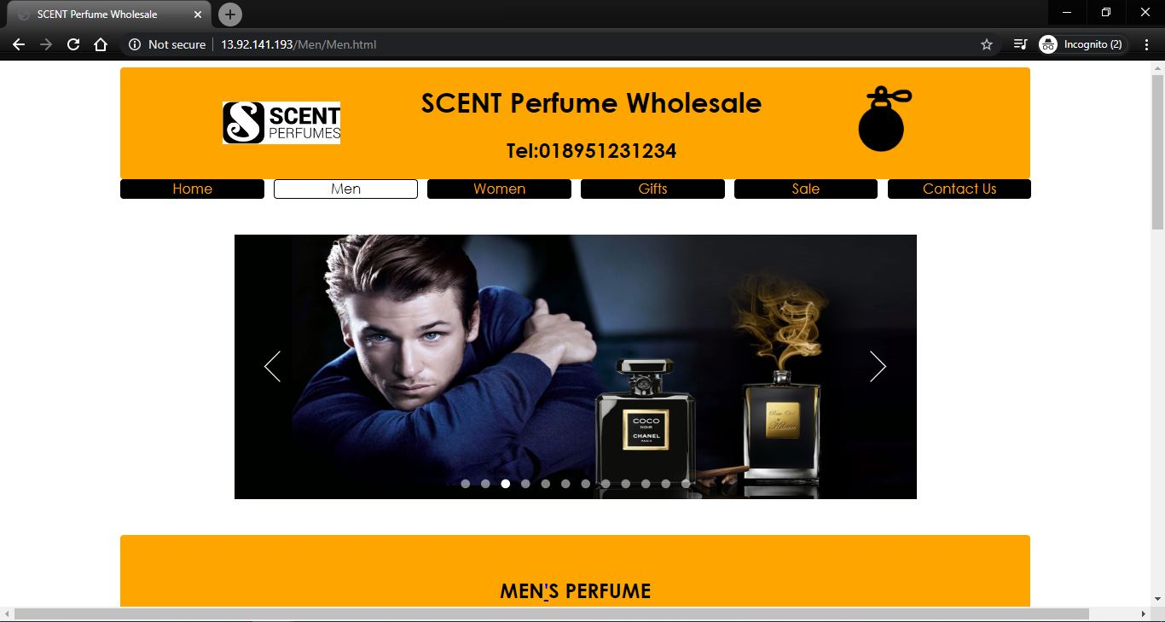

**Women’s Page -**

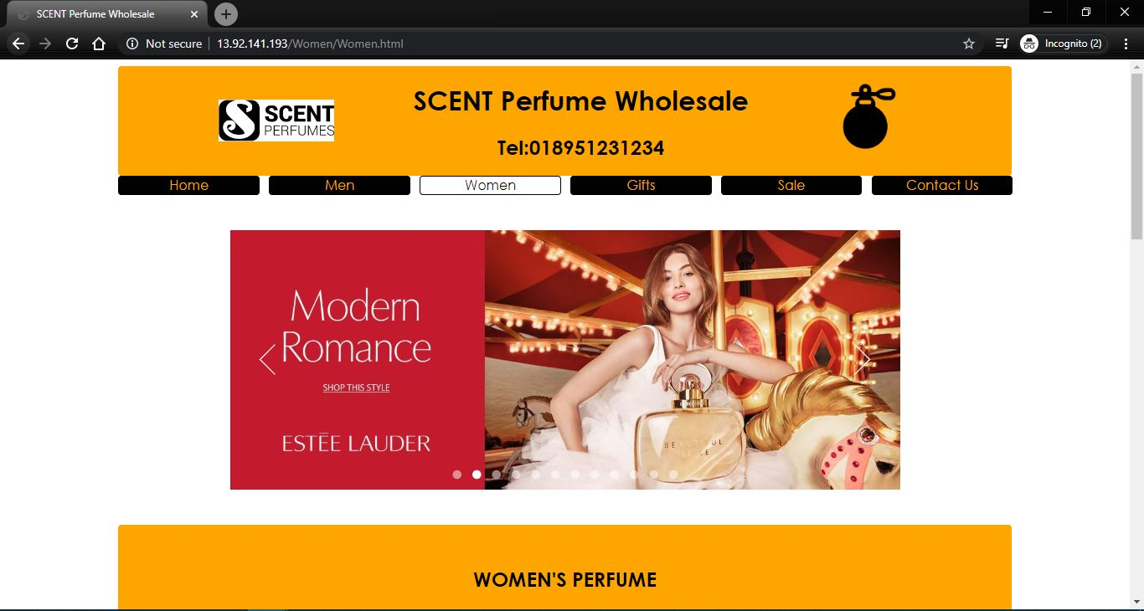

**Gift’s Page -**

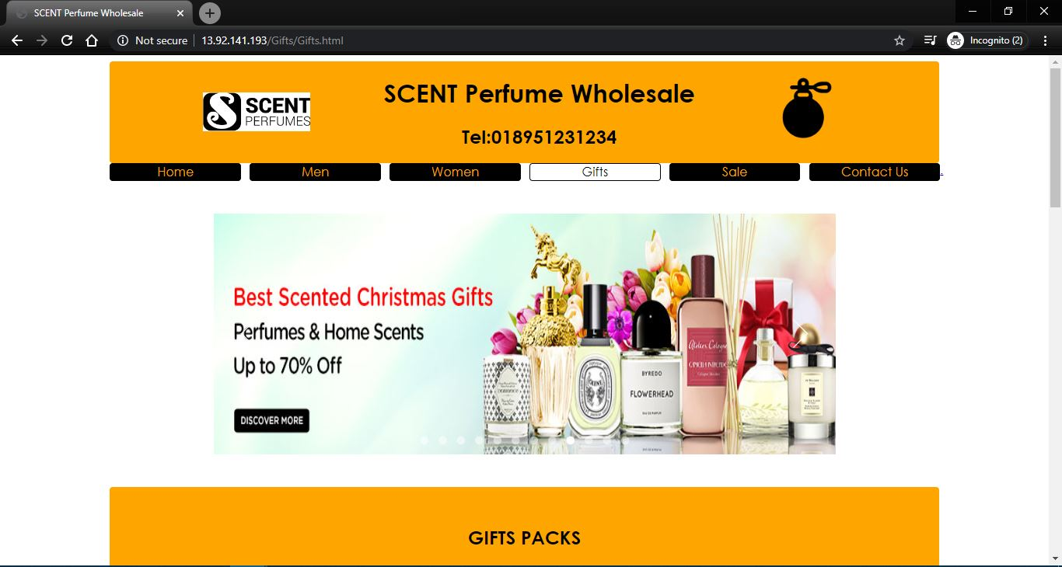

**Sale’s Page -**

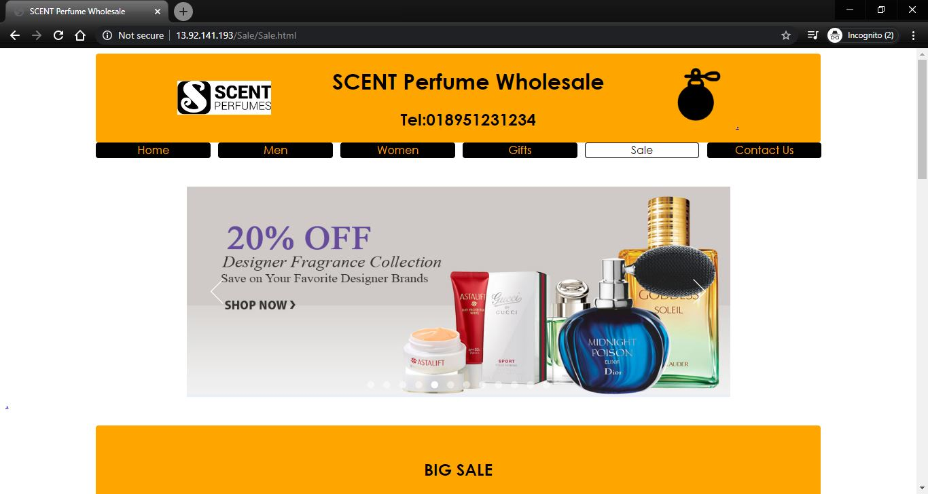

**Contact’s Page -**

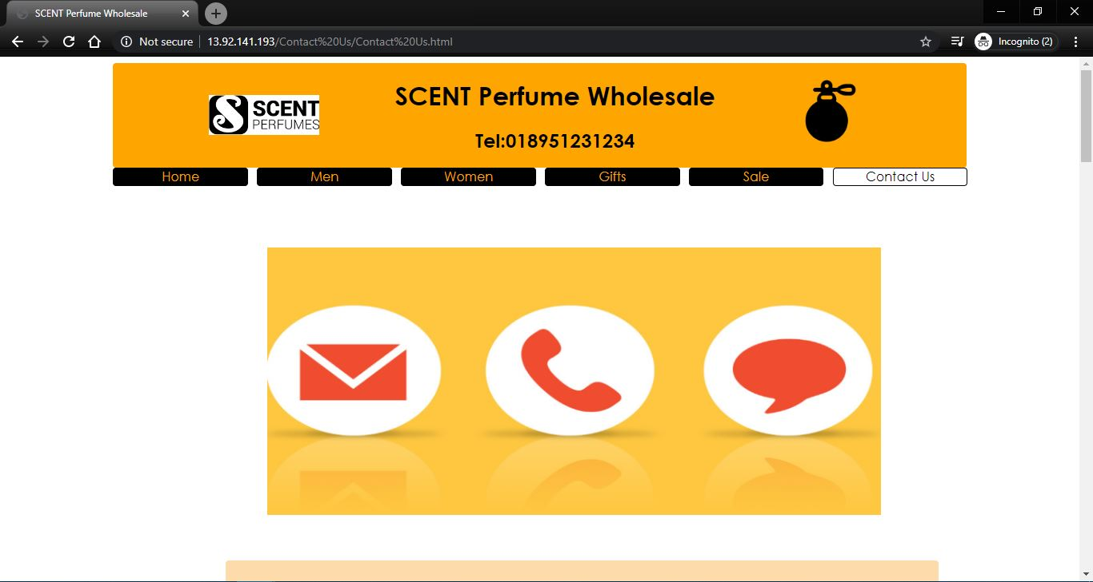

**Issues faced while hosting Website -**

**Adding / Creating A Server -**

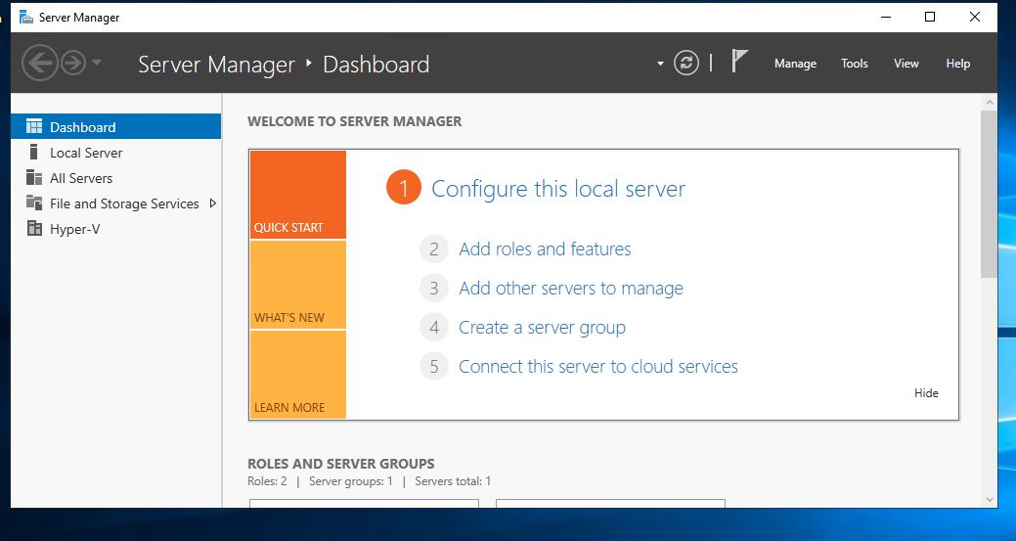

**Style (.css) not loading -**

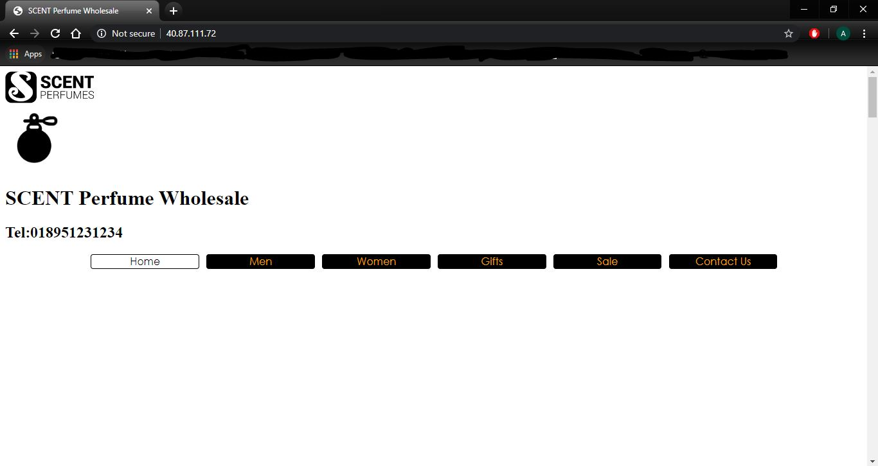

**3) Slow Website Load times -**

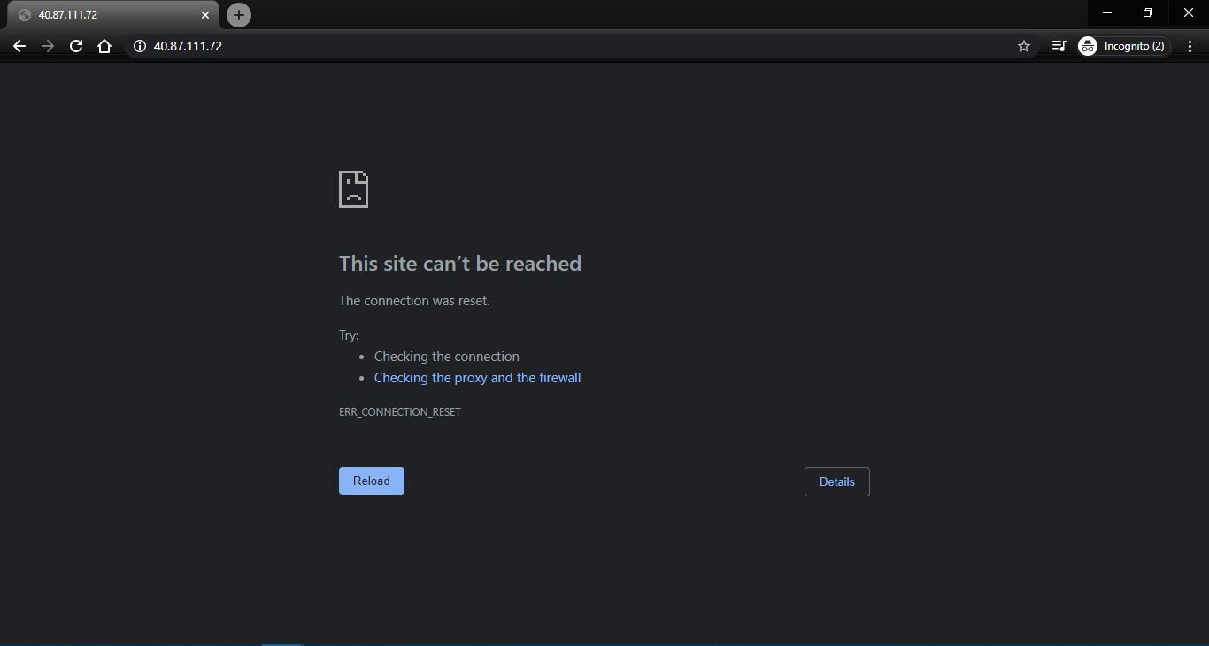

**Basic Monthly Usage of Vms for East US -**

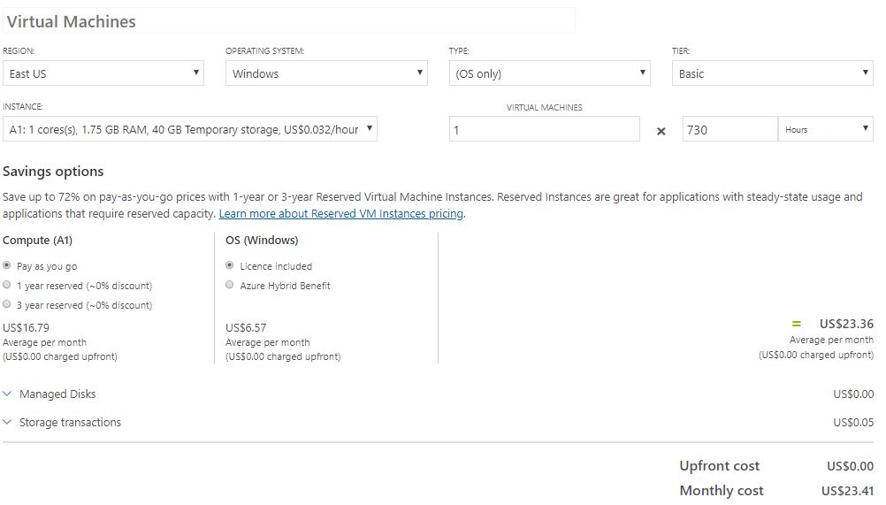

**Low Priority Monthly Usage of Vms for East US -**

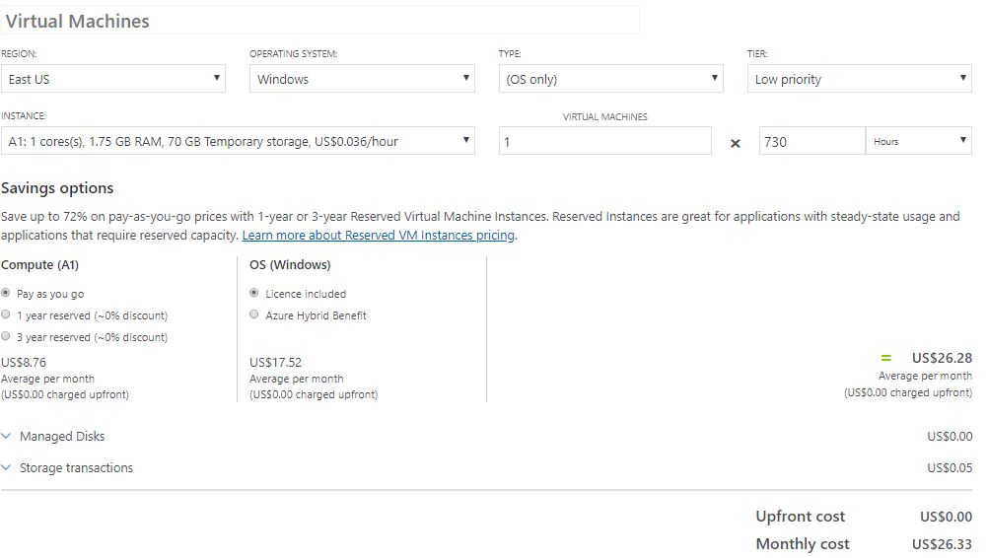

**Standard Monthly Usage of Vms for East US -**

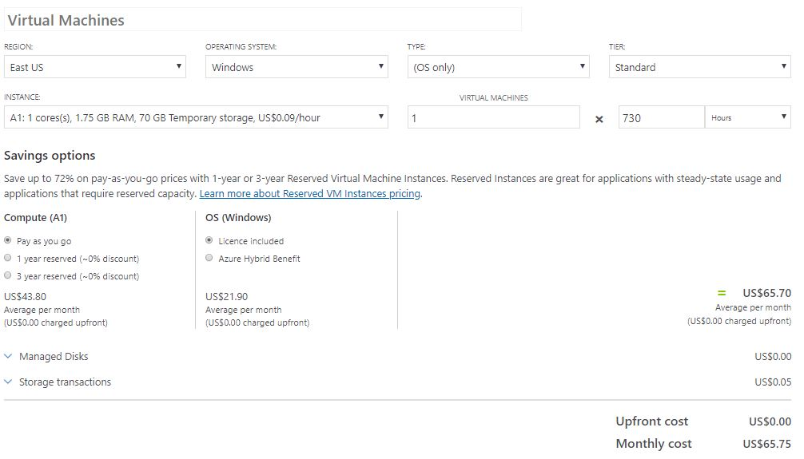

**Basic Monthly Usage of Vms for West Europe -**

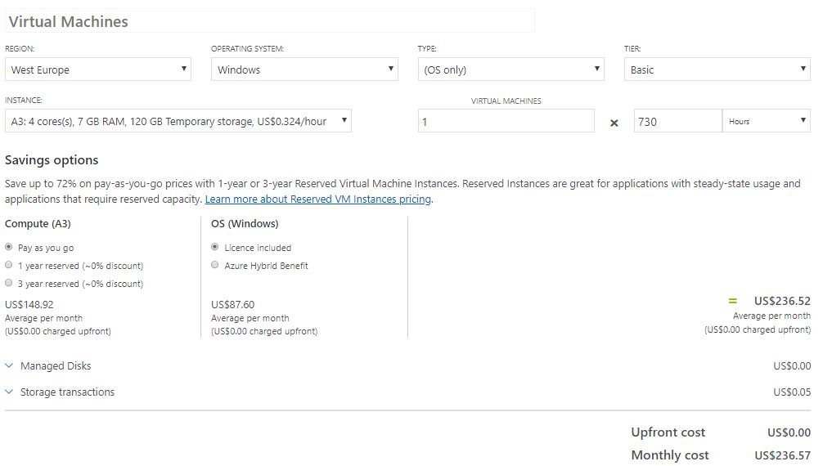

**Low Priority Monthly Usage of Vms for West Europe -**

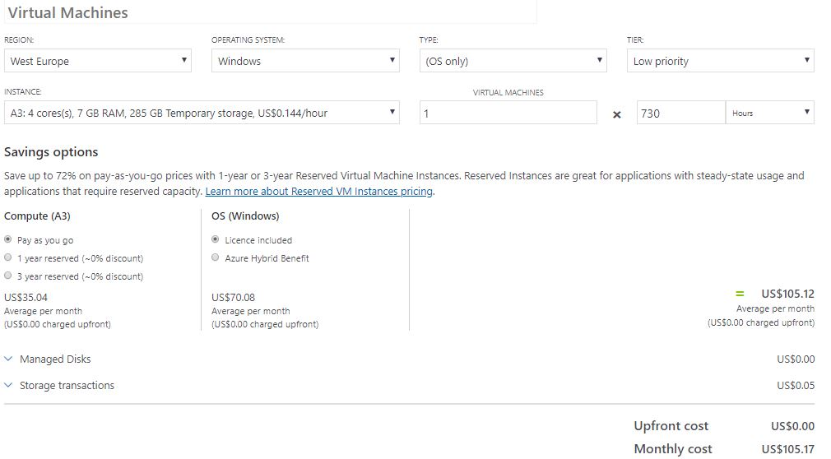

**Standard Monthly Usage of Vms for West Europe -**

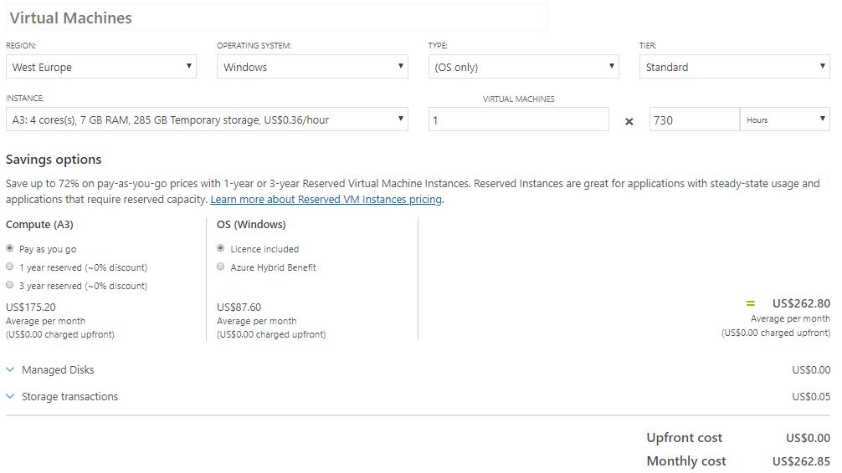

**Azure Basic Monthly Usage of Vms for UK West -**

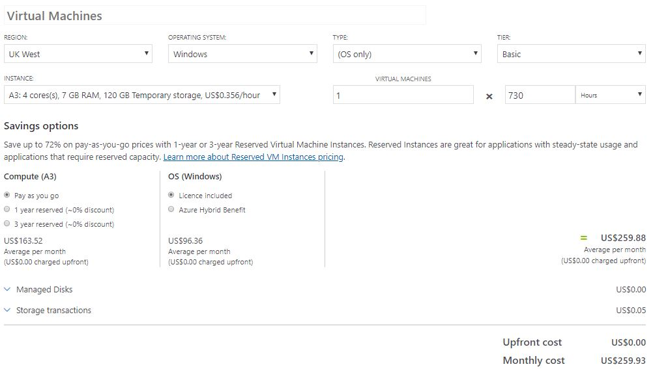

**Azure Low Priority Monthly Usage of Vms for UK West -**



**Azure Standard Monthly Usage of Vms for UK West -**

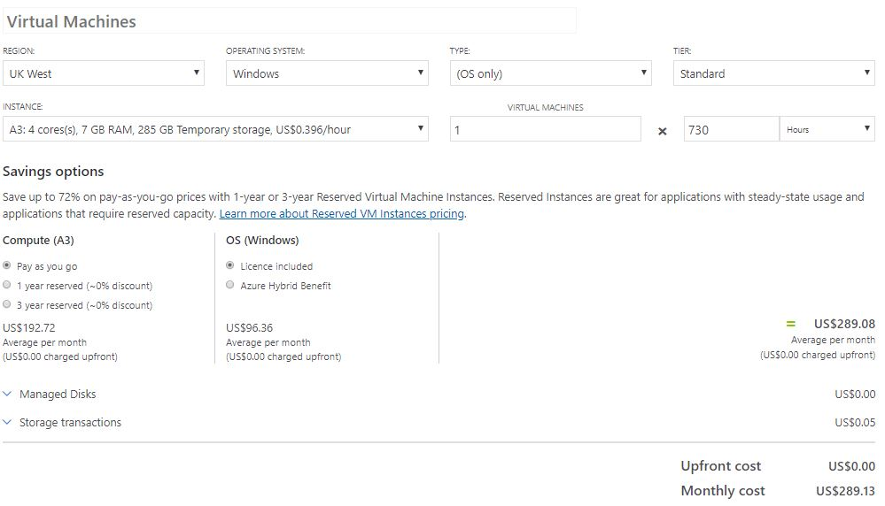

**AWS Standard Monthly Usage of Vms for East US (Ohio) -**

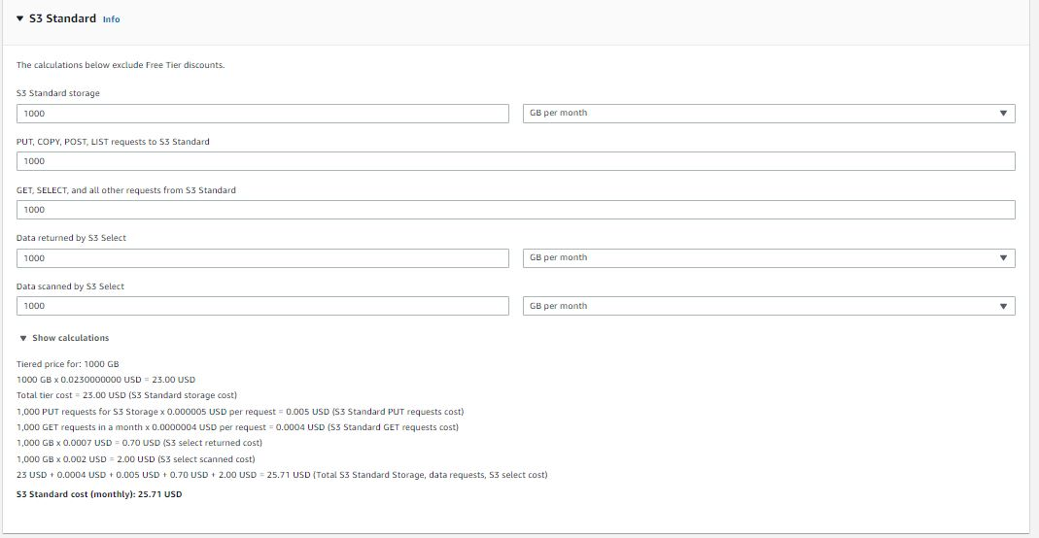

**AWS Standard Monthly Usage of Vms for EU (London) -**

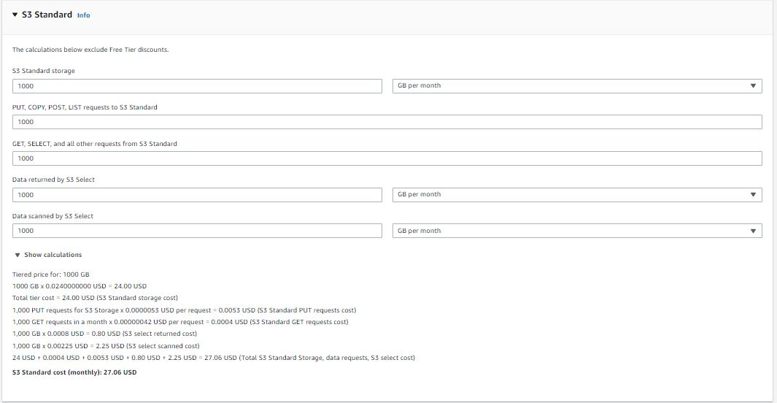

**AWS Standard Monthly Usage of Vms for EU (Ireland) -**



